Previous Winners

Year | Horse /  Owner |  | Age/  Sex | Trainer /  Jockey | Rep. | Wt. | Win.  Margin | Draw | Odds | Going | Race Time | Int’l Rating | Form  (Last 5) | Best Performance Last  12 months (Runs since)
2014 | Aerovelocity (NZ) |  | 6g | P O’Sullivan | HK | 126 | N | 7 | 3.9 | GF | 1.08.57 | 112 | 11210 | 2nd Premier Bowl 1200 (G2) (1)
 | Daniel Yeung Ngai |  |  | Z Purton |  |  |  |  |  |  |  |  |  | 2nd Premier Bowl 1200 (G2) (1)
2013 | Lord Kanaloa (JPN) | 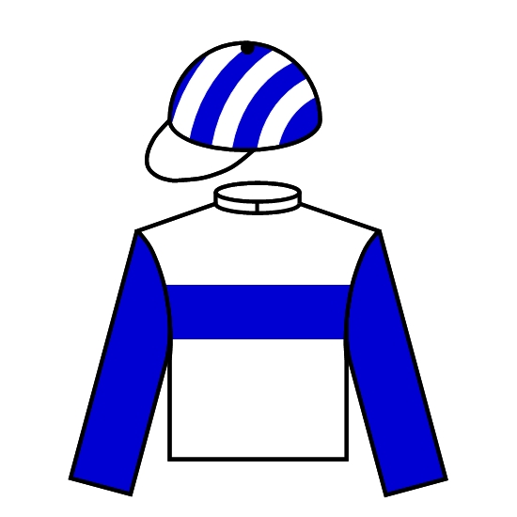 | 5h | T Yasuda | JPN | 126 | 5 | 12 | 1.8F | GF | 1.08.25 | 120 | 11121 | Won Yasuda Kinen 1600 G1 (2)
 | Lord Horse Club |  |  | Y Iwata |  |  |  |  |  |  |  |  |  | Won Yasuda Kinen 1600 G1 (2)
2012 | Lord Kanaloa (JPN) |  | 4c | T Yasuda | JPN | 126 | 2-1/2 | 6 | 4 | G | 1.08.50 | 117 | 13221 | Won Sprinters Stakes 1200 G1 (0)
 | Lord Horse Club |  |  | Y Iwata |  |  |  |  |  |  |  |  |  | Won Sprinters Stakes 1200 G1 (0)
2011 | Lucky Nine (IRE) |  | 4g | C Fownes | HK | 126 | HD | 6 | 4.3 | GF | 1.08.98 | 117 | 23225 | 2nd BMW Champions Mile 1600 G1 (2)
 | Dr. Chang Fuk To & Maria Chang Lee Ming Shum |  |  | B Prebble |  |  |  |  |  |  |  |  |  | 2nd BMW Champions Mile 1600 G1 (2)
2010 | J J The Jet Plane (SAF) |  | 6g | L Houdalakis | SAF | 126 | SH | 8 | 18 | G | 1.08.84 | 120 | 43911 | Won Mercury Sprint 1200 G1 (0)
 | H S N Du Preez, C F Strydom,  Ms C D Boyens & M N Houdalakis |  |  | P Strydom |  |  |  |  |  |  |  |  |  | Won Mercury Sprint 1200 G1 (0)
2009 | Sacred Kingdom (AUS) |  | 6g | P F Yiu | HK | 126 | 1/2 | 7 | 2.5F | G | 1.09.16 | 122 | 61152 | Won KrisFlyer Int'l Sprint 1200 (G1) (2)
 | Sin Kang Yuk |  |  | B Prebble |  |  |  |  |  |  |  |  |  | Won KrisFlyer Int'l Sprint 1200 (G1) (2)
2008 | Inspiration (AUS) |  | 5g | J Moore | HK | 126 | Nk | 9 | 67 | G | 1.08.68 | 106 | 20157 | 7th Sprint Trial 1200 (G2) (0)
 | Mr & Mrs Hui Sai Fun |  |  | D Beadman |  |  |  |  |  |  |  |  |  | 7th Sprint Trial 1200 (G2) (0)
2007 | Sacred Kingdom (AUS) |  | 4g | P F Yiu | HK | 126 | 2-1/4 | 6 | 1.4F | G | 1.08.4 | 120 | 12142 | Won Sprint Trial 1200 (G2) (0)
 | Sin Kang Yuk |  |  | G Mosse |  |  |  |  |  |  |  |  |  | Won Sprint Trial 1200 (G2) (0)
2006 | Absolute Champion (AUS) |  | 5g | D J Hall | HK | 126 | 4-1/4 | 5 | 6.4 | GF | 1.07.8 | 108 | 35411 | Won Premier Bowl hcp 1200 (G3) (0)
 | Mr & Mrs Eddie Wong Ming Chak |  |  | B Prebble |  |  |  |  |  |  |  |  |  | Won Premier Bowl hcp 1200 (G3) (0)
2005 | Natural Blitz (AUS) |  | 5g | D Cruz | HK | 126 | 1-3/4 | 2 | 28 | GF | 0.57.6 | 100 | 60403 | 3rd Sprint Trial 1000 (G2) (0)
 | Lam Yin Kee |  |  | G Schofield |  |  |  |  |  |  |  |  |  | 3rd Sprint Trial 1000 (G2) (0)

