LONGINES Hong Kong Mile (Group 1)
HK$23 million (US$3.0 million)
1st HK$13,110,000, 2nd HK$5,060,000, 3rd HK$2,300,000,
4th HK$1,311,000, 5th HK$759,000, 6th HK$460,000

Performance Analysis

Horse Details |  |  |  |  |  | Horse Statistics |  |  |  |  |  |  | Probable Jockey | Trainer
Name |  | Rep | Age/  Sex | Wt. | Int’l Rtg | Lifetime | G1 | Good | Wet | RH | 1400-1800 | Trk/Dist | Probable Jockey | Trainer
Able Friend |  | HK | 6G | 126 | 125 | 21 (13-4-2) | 6 (4-1-0) | 21 (13-4-2) | 0 (0-0-0) | 20 (13-4-2) | 16 (11-2-2) | 10 (8-1-1) | J Moreira | J Moore
Maurice |  | JPN | 4C | 126 | 119 | 12 (7-0-1) | 2 (2-0-0) | 12 (7-0-1) | 0 (0-0-0) | 10 (6-0-1) | 11 (7-0-1) | 0 (0-0-0) | R Moore | N Hori
Beauty Flame |  | HK | 5G | 126 | 118 | 25 (6-7-3) | 2 (0-2-0) | 23 (5-7-3) | 2 (1-0-0) | 21 (4-7-3) | 22 (6-7-3) | 7 (1-3-1) | G Mosse | A S Cruz
Mondialiste | 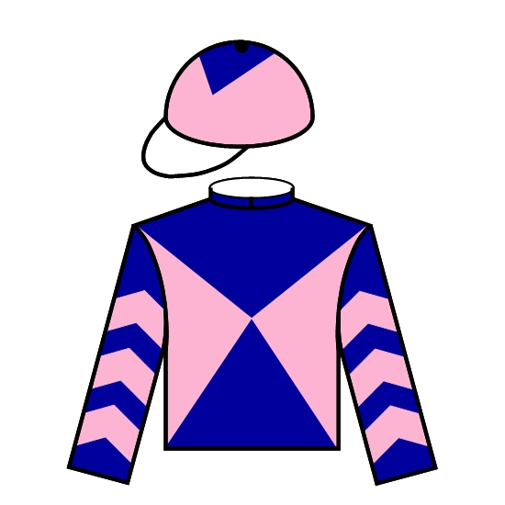 | GB | 5H | 126 | 118 | 16 (4-4-5) | 3 (1-1-1) | 9 (2-2-2) | 5 (2-1-2) | 5 (0-1-2) | 15 (4-3-5) | 0 (0-0-0) | D Tudhope | D O'Meara
Toormore |  | GB | 4C | 126 | 118 | 15 (6-2-3) | 8 (1-1-2) | 10 (4-2-1) | 5 (2-0-2) | 6 (3-1-2) | 14 (5-2-3) | 0 (0-0-0) | J Doyle | R Hannon
Fiero |  | JPN | 6H | 126 | 116 | 17 (5-5-3) | 5 (0-2-0) | 14 (3-5-3) | 3 (2-0-0) | 10 (2-5-2) | 17 (5-5-3) | 1 (0-0-0) | M Demuro | H Fujiwara
Contentment |  | HK | 5G | 126 | 115 | 12 (8-2-0) | 0 (0-0-0) | 12 (8-2-0) | 0 (0-0-0) | 12 (8-2-0) | 11 (8-2-0) | 5 (3-2-0) | N Rawiller | J Size
Rewarding Hero |  | HK | 6G | 126 | 115 | 35 (8-4-5) | 3 (0-1-1) | 32 (7-4-5) | 2 (1-0-0) | 35 (8-4-5) | 30 (7-4-5) | 15 (3-4-2) | D Whyte | J Moore
Red Dubawi |  | GER | 7H | 126 | 113 | 42 (5-2-8) | 2 (1-0-0) | 17 (3-2-2) | 21 (2-0-6) | 9 (1-2-2) | 21 (4-1-3) | 0 (0-0-0) | A Suborics | E Mader
Giant Treasure |  | HK | 4G | 126 | 112 | 14 (4-1-4) | 0 (0-0-0) | 11 (3-1-3) | 2 (1-0-1) | 12 (3-1-3) | 13 (4-1-4) | 4 (0-0-2) | C Soumillon | R Gibson
Romantic Touch |  | HK | 5G | 126 | 112 | 25 (5-1-2) | 2 (1-0-0) | 20 (4-1-1) | 5 (1-0-1) | 23 (5-1-2) | 18 (5-1-0) | 2 (0-0-0) | N Callan | A S Cruz
Secret Sham |  | HK | 6G | 126 | 111 | 31 (8-3-1) | 3 (0-0-0) | 26 (7-2-1) | 5 (1-1-0) | 30 (8-3-1) | 21 (6-1-1) | 9 (0-1-0) | T Berry | J Moore
Danon Platina |  | JPN | 3C | 125 | 114 | 7 (4-1-1) | 2 (1-0-0) | 7 (4-1-1) | 0 (0-0-0) | 4 (1-1-1) | 6 (4-1-1) | 0 (0-0-0) | M Ebina | S Kunieda
Esoterique |  | FR | 5M | 122 | 119 | 17 (6-3-1) | 10 (3-3-0) | 12 (3-3-0) | 5 (3-0-1) | 4 (1-1-0) | 14 (5-2-1) | 0 (0-0-0) | P-C Boudot | A Fabre

International Ratings Chart Speed Chart

Average performance rating of 5 most recent winners = 120.  * 4 lb. weight allowance added to rating for fillies and mares | 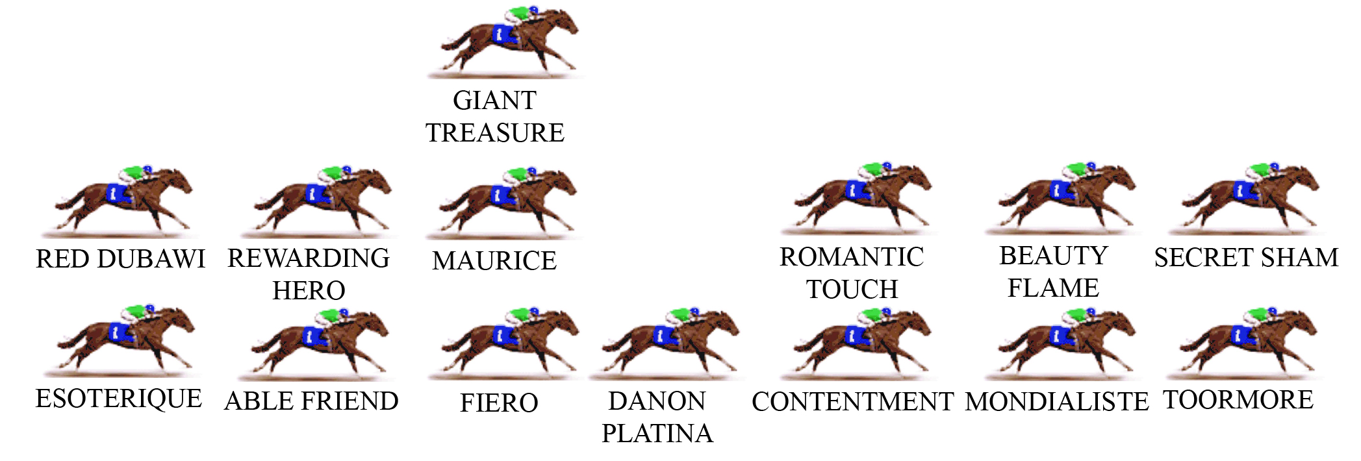  This year’s Mile looks like being run evenly, with two options for leader and a few others to race handy. A curiosity of the HK Mile over the years is that a large percentage of winners have come from a similar position, back in the field and three wide (with cover). Think of OLYMPIC EXPRESS, HAT TRICK, GOOD BABA (3 times winner) and GLORIOUS DAYS. Also worth mentioning last year’s stunning winner ABLE FRIEND, who was 10 lengths off the lead at the 800m before storming to the easiest of wins.
  Name | International Rating
  Able Friend |  |  |  |  |  |  |  |  |  |  |  |  |  |  |  |  |  |  |  |  |  |  |  |  |  |  | 125
  Maurice |  |  |  |  |  |  |  |  |  |  |  |  |  |  |  |  |  |  |  |  |  | 119
  Beauty Flame |  |  |  |  |  |  |  |  |  |  |  |  |  |  |  |  |  |  |  |  |  | 118
  Mondialiste |  |  |  |  |  |  |  |  |  |  |  |  |  |  |  |  |  |  |  |  |  | 118
  Toormore |  |  |  |  |  |  |  |  |  |  |  |  |  |  |  |  |  |  |  |  |  | 118
  Fiero |  |  |  |  |  |  |  |  |  |  |  |  |  |  |  |  |  | 116
  Contentment |  |  |  |  |  |  |  |  |  |  |  |  |  |  |  |  | 115
  Rewarding Hero |  |  |  |  |  |  |  |  |  |  |  |  |  |  |  |  | 115
  Red Dubawi |  |  |  |  |  |  |  |  |  |  |  |  |  |  | 113
  Giant Treasure |  |  |  |  |  |  |  |  |  |  |  |  |  | 112
  Romantic Touch |  |  |  |  |  |  |  |  |  |  |  |  |  | 112
  Secret Sham |  |  |  |  |  |  |  |  |  |  |  |  | 111
  Danon Platina |  |  |  |  |  |  |  |  |  |  |  |  |  |  |  | 114
  Esoterique |  |  |  |  |  |  |  |  |  |  |  |  |  |  |  |  |  |  |  |  |  |  |  |  | 119+4

