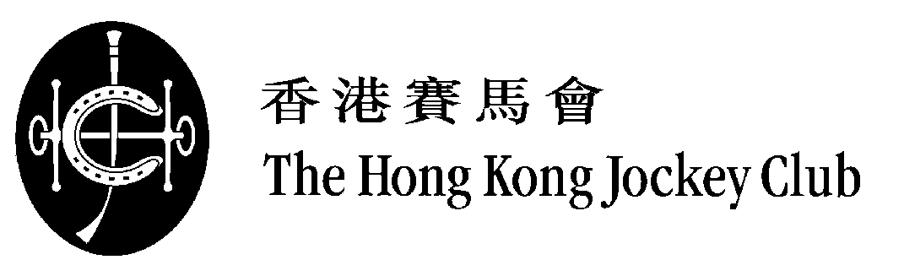

2016 LONGINES Hong Kong International Races

Selected Runners

(as at 28/11/2016)

LONGINES Hong Kong Sprint (Group 1) – 1200m
HK$18.5 million (US$2.385 million)

Country / Region | Int'l Rating | Selected Horse |  | Age | Sex | Weight | Trainer
HK | 119 | * | AEROVELOCITY (NZ) | 8 | g | 126 | Paul O'Sullivan
HK | 119 |  | LUCKY BUBBLES (AUS) | 5 | g | 126 | Francis Lui
HK | 119 | * | PENIAPHOBIA (IRE) | 5 | g | 126 | Tony Cruz
HK | 118 |  | NOT LISTENIN'TOME (AUS) | 6 | g | 126 | John Moore
HK | 117 |  | AMAZING KIDS (NZ) | 5 | g | 126 | John Size
JPN | 117 | * | BIG ARTHUR (JPN) | 5 | h | 126 | Kenichi Fujioka
AUS | 117 | * | REBEL DANE (AUS) | 7 | h | 126 | Gary Portelli
FR | 117 | * | SIGNS OF BLESSING (IRE) | 5 | g | 126 | François Rohaut
JPN | 116 | * | RED FALX (JPN) | 5 | h | 126 | Tomohito Ozeki
HK | 116 |  | STRATHMORE (AUS) | 5 | g | 126 | Tony Millard
GB | 114 |  | GROWL (GB) | 4 | g | 126 | Richard Fahey
AUS | 113 | * | TAKEDOWN (AUS) | 4 | g | 126 | Gary Moore
USA | 112 |  | PURE SENSATION (USA) | 5 | g | 126 | Christophe Clement
HK | 112 |  | SUPER JOCKEY (NZ) | 8 | g | 126 | Tony Millard
 |  |  | (14)
* International Group 1 winner
Withdrawn:
GB | PROFITABLE (IRE)

Nigel Gray
Head of Handicapping,
Race Planning and International Racing

